Yr 1B | 8.55 | 9.00  –  9.30 | 9.30-10.30 | 10.30 – 10.45 | 10.45 – 11:30 | 11:30 – 12:00 |  | 12.00 – 1:15 | 1.15 – 1:45 |  | 1:45 – 14:15 | 14:15 – 14.30 | 14:30 – 15:15 |  | 15.15 – 15:30
M | Registration | Literacy | Phonics & Writing | Break time | Maths PPA | Assembly |  | Lunch | Maths Meet |  | RE/Topic PPA | Break time | Topic |  | 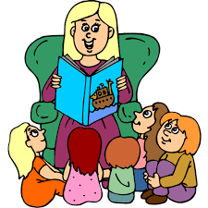  Story Time
T |  | Literacy | Phonics & Writing |  | Maths |  |  |  | Handwriting | PE |  |  | Science |  | Story Time
W |  | Literacy | Phonics & Writing |  | Music PPA | Maths |  |  | Topic |  |  |  | 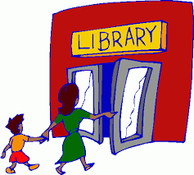  Library |  | Story Time
T |  | Literacy | Phonics & Writing |  | Swimming |  |  |  | Maths |  |  |  | Secret Garden |  | Story Time
F |  | KS1 Assembly | English/Phonics |  | Maths |  | Handwriting |  | Maths Meet |  | Computing |  | Phonic Words | PSHE | Story Time

Blocked subjects this term:

