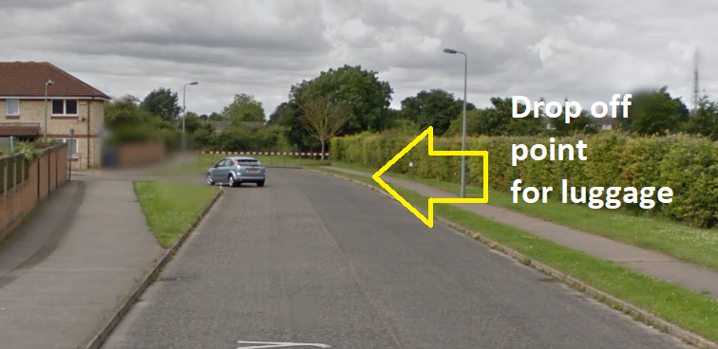
Aylmerton Residential Trip – 9th March – 11th March 2020

Key information
Please arrive at Aberdeen way (school back gates) to drop off any luggage by 8.30am. Mr. Smith will be there to put the luggage onto the coach.
If you have medication, please arrive by 8.15am. All medication is to be named and given to Mrs. Ching in the South Hall on arrival.

Once you have dropped off your luggage, please head to the South Hall, where Miss. Clarke will register you and you will be instructed to gather into your groups with your group leader. We are hoping to leave Rushmere between 8.45am and 9.00am. You are more than welcome to wave us goodbye at Aberdeen Way!
On the coach journey, we are happy for children to bring one small snack each. Please avoid any snacks that contain nuts, and preferably no chocolate.
The children are allowed to bring up to £5 of pocket money. Please bring this into school before the school trip and pass this to your child’s class teacher. The money should be in an envelope or purse and named/labelled with your child’s class. We will store the money safely and group leaders will look after their group’s money.

On the Monday we depart (9th March), the children will need to bring their own packed lunch. If your child is entitled to free school meals, the school will be able to provide a packed lunch for them. Please let us know as soon as possible if this applies to your child.
We are leaving Aylmerton at 1pm on Wednesday 11th March. We hope to return to school by 3.30pm. It is a 2 hour coach journey but of course our journey will be traffic dependent. The school will keep you updated of our arrival time, in case of any changes.

Please do not block the Abderdeen Way entrance at departure and arrival times.

