Home School
Outdoor Learning Ideas

Treasure Hunt, working in pairs, hide ‘treasure’ and use garden items to make map on the ground to show where the treasure is located, eg sticks for trees, and arrows, leaves for paths etc. Once treasure found, swap over hiders and seekers

Caterpillars, Each child finds two short sticks (caterpillar feelers) shut eyes. Adult taps drum or claps hands and the ‘caterpillars’ follow the sound around the garden

Bat & Moth, stand in a circle, one child in middle ‘bat’ and another child in middle ‘moth’ both children are blindfolded, the ‘bat’ shouts ‘bat’ and the ‘moth’ shouts ‘moth’ and they have to find each other
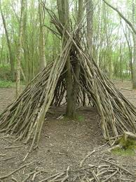
Den Building use ropes, tarpaulin, sheets, sticks, ferns etc to construct dens, these dens (if secure enough) can be kept for use each week

Woven Teepees Use 3x large sticks or garden canes, secure the ends and push the other ends into the ground to make a tripod shape.

Web Building Use ropes and bungee cord, weave and thread them between and around trees to create ‘spider webs’ challenge the children to get through the webs. Increase the level of difficulty e.g. blindfolded, only touch the ground twice etc.

Rope Trail tie heavy duty ropes from tree to tree to make a ‘path’ between the trees, follow the path with eyes closed/blind folded

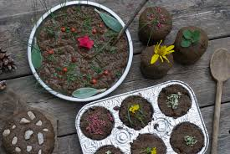
Mud Kitchen Create a simple mud kitchen using old pots, pans, containers and utensils. Explore using mud to make pretend cakes etc. Have a pretend ‘tea party.’ Create and design menus for a pretend mud pie restaurant.

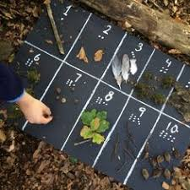
Maths Games Find numbers of objects from the garden environment to match numbers given. Or, use garden items to compete addition/subtraction sums.
Or, use garden items to create times tables.
Or, collect sticks and arrange in length order.
Or collect leaves and arrange in size order.

2D Shapes Find sticks or other items outside to create 2D shapes, use these shapes to create pictures. Identify shapes used, practise knot skills to fasten shapes made.
Use shapes to create repeating patterns.
Make different size shapes and sort in order.
Estimate using shapes, how many leaves will fit in the square?

Picture Frames tie four sticks together (lash the corners) to make a ‘frame’ place the stick frame on the ground and create a picture within the frame using things they find in the garden. Ideas for pictures include; an animal, a self portrait, a particular plant or species, a landscape, a map, art in the style of a famous artist etc

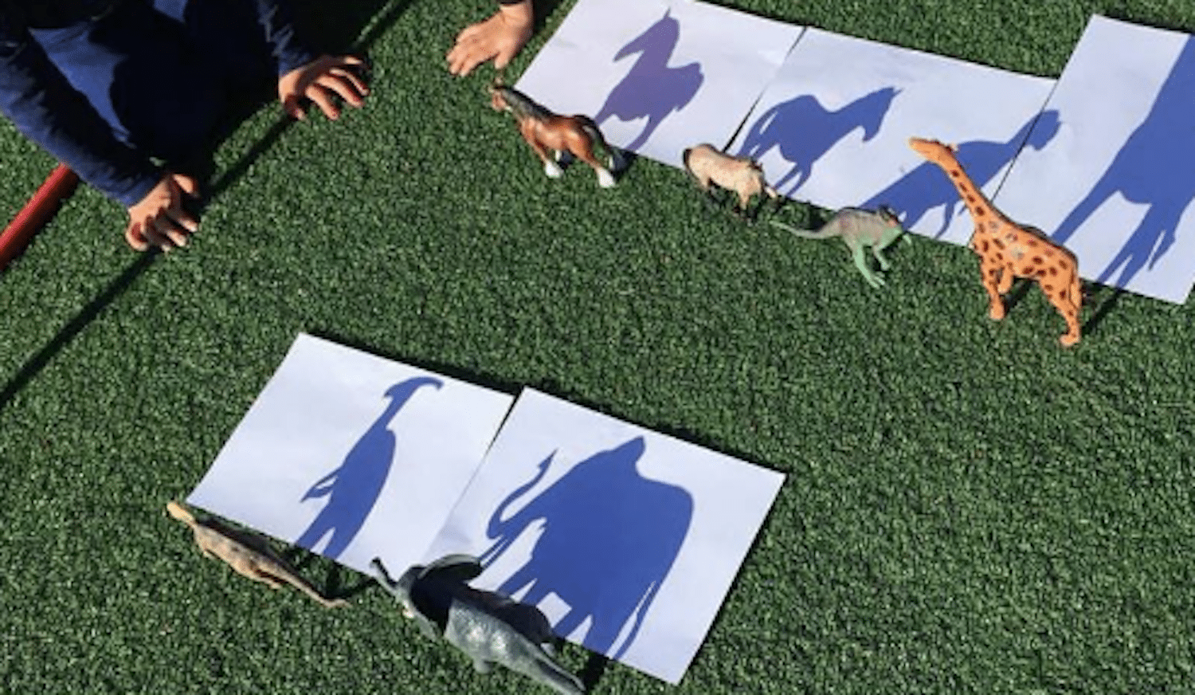
Shadow Pictures Place paper on the ground and draw around the shadows of different objects. Could use toys such as animals figures, dinosaurs etc

Mud Totem Poles create mud faces on tree trunks, add sticks for hair, teeth, stones for eyes etc, add mud faces to the same tree trunk to create a totem pole effect
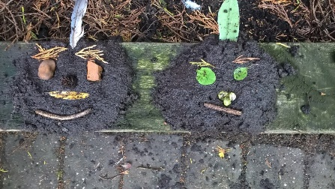
Mud Faces create mud faces add sticks for hair, teeth, stones for eyes etc, Or create mud animals, mud monsters, mud characters from story books etc

Whittling use potato peelers to whittle sticks (IMPORTANT must wear gloves for this activity, sit or kneel on ground and ‘whittle’ away from the body) Sticks could be used to make ‘pens’ and use blackberry juice for example to ‘write’ or ‘draw/paint’ pictures
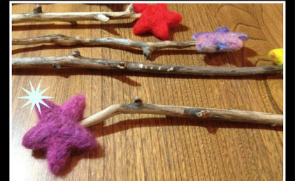

Willow Fairy Wands willow twigs and branches will bend without snapping, use to make dream catchers and fairy wands, bend willow into desired shape and secure with string. Decorate with items found in the garden
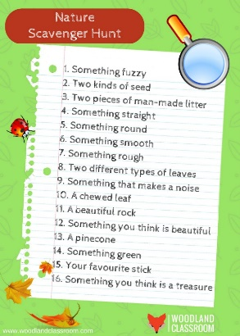

Scavenger Hunts Variations for this activity are endless, eg find items in a list, find things that are green, find things bigger than/smaller than, find 5 things, find things beginning with the sound…

Mummy Bird Game in pairs, partner one is Mummy Bird given a bird or animal ‘call’ (eg owl, crow, cuckoo) Mummy birds stand in their ‘nests’ (a corner of the garden) to make the appropriate call. Then partner two is Baby Bird, they stand in middle of garden (blindfolded or eyes closed) and have to follow the sounds back to their correct ‘nest’

Tree Identification In pairs, one partner eyes shut/blindfolded, walk partner over to tree, can feel it, smell it etc, walk back to middle of garden. Remove blindfold, can they find which tree they touched?

Bird Feeders Mix lard with warm water and seeds, find a stick and wrap the lard & seeds mixture around the stick, hang the bird feeders in the trees

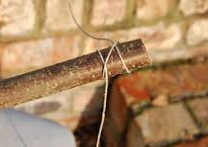
Knot Tying Learn and practise tying different knots, how many can you do? Use what they’ve learnt to secure dens etc.

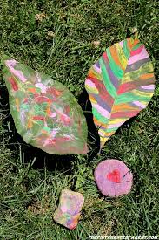
Nature Painting Use chalks and/or paints to decorate leaves

Leaf Garland Collect leaves, use hole punch to make a hole in each leaf and thread onto string to create leaf garlands for decoration

Leaf Bunting Collect leaves, place vein side down onto material, cover and bash the leaves with mallet/stone or similar. The leaf veins will make an imprint on the material, use for bunting etc.

Stone/Rock Painting Use paints to decorate stones and rocks. Try painting ladybirds, or other garden creatures, or animals, patterns or even your name

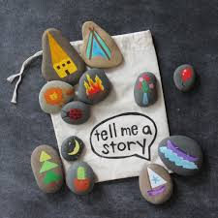

Story Stones Create story stones. Paint a collection of stones taking inspiration from a favourite book or simply paint a variety of objects/images eg castles, forest.
Use the stones to retell a favourite story.
Or place the stones in a bag and take out one by one and use to create a story. The story could be retold verbally or could be written down to create a story book.

Stepping Stones 5x stepping-stones can they use the stepping-stones to get across the garden without touching the floor

Sit Spot Find a ‘sit spot’, sit for 1 min and listen/observe in silence. Each week increase length of time sitting 2mins, 5mins etc Discuss/draw/write, what did you hear, see, observe etc.

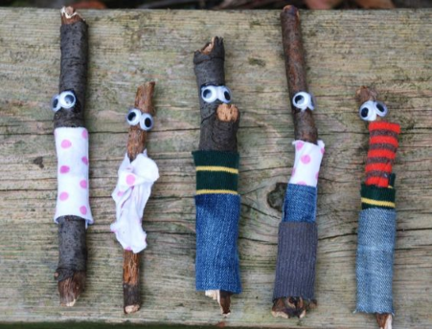
Stick Men Read and share the Stick Man story (Julia Donaldson) find a stick, paint and decorate, add eyes etc. Use material for clothes. Find different size sticks to create a Stick Family.

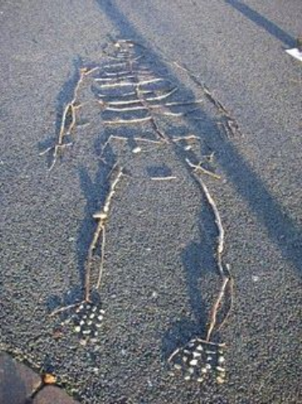
Stick Skeleton Find different size sticks to create a ‘stick skeleton’ name and label the different bones e.g. ribs, skull, hips etc. Try creating ‘stick skeleton’ animals.

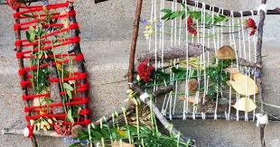
Weaving Tie four sticks together to create a frame, attach wool strands and create a weaving using natural objects

Websites for further ideas…

www.suffolkwildlifetrust.org/calendar - tells you what to look for in the environment at different times/months of the year.

www.forestry.gov.uk/england-learning - lots of lesson plans and ideas for EYFS/KS1/KS2

www.woodlandtrust.org.uk/nature detectives – a series of lesson plans and activities based upon ‘nature detective’ theme EYFS/KS1

