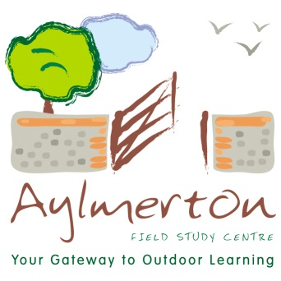
SUGGESTED CLOTHING
AND KIT LIST

Please don’t bring new or expensive clothing. There is a very high chance you might get dirty or wet – or both!

We will hold lost property for two weeks after the visit. Please ensure all items are named to help with “repatriation”. Unfortunately, we cannot accept responsibility for visitor’s property and valuable items are therefore brought at your own risk.

ABSOLUTELY ESSENTIAL ITEMS!

- Single duvet cover and pillowcase
- WATERPROOF coat with HOOD (and ideally waterproof trousers too)
- Walking boots or STURDY trainers (no Converse, slip on shoes or open toed sandals)
- Wellington boots (the River Study is only possible with LONG boots)
- Slippers or other indoor footwear (compulsory inside)
- Warm hat, gloves, scarf (at all times except summer though hat is useful even in summer)
- Suncream and sun hat (at all times except winter)
- Lightweight tops for layering – 2 or 3 (in summer shoulders MUST be covered so no strappy tops please and, ideally, one top with a collar to cover the back of the neck)
- Warm jumpers/tops – at least 2
- Trousers/tracksuit bottoms – 2 or 3 pairs – NOT JEANS (for Blakeney days they must be loose enough to roll above the knee)
- Socks – several pairs – NOT TRAINER/SECRET SOCKS (sand causes blisters!)
- Underwear/Nightwear/Towel/Toiletries (don’t forget your toothbrush!)
- Swimsuit/extra towel/£1 coin for lockers (only if swimming)
- Small BACKPACK (no other style of bag) with TWO THICK STRAPS
- Water bottle
- Pocket money (check with school for appropriate amount)
- Bin bag for wet/dirty clothes
- PACKED LUNCH (for first day only)

Please note that groups going into the woods at any time of year will need to have LONG SLEEVES AND TROUSERS to prevent tick bites (a lightweight version of each would be nicer in summer) as well as LONG SOCKS (long enough to tuck trousers into).

Please do not bring any aerosols or spray suncream as they set off our very sensitive fire alarms!

THE ABOVE SHOULD BE PACKED IN A MEDIUM SIZED CASE/BAG THAT YOUR CHILD IS ABLE TO CARRY COMFORTABLY FOR A SHORT DISTANCE UP A FLIGHT OF STAIRS ON ARRIVAL WITH US. IT MUST ALSO BE ABLE TO FIT UNDERNEATH A NORMAL BED.

LARGE SUITCASES THAT CANNOT FIT UNDER A NORMAL BED ARE AN OBSTRUCTION HAZARD IN THE EVENT OF EVACUATION DURING A FIRE ALARM.

